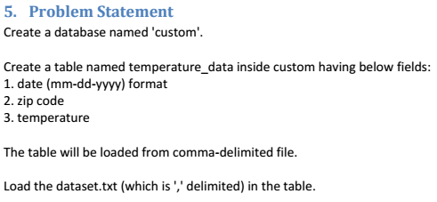

**Solution:-**

As per the below screenshot, there is no database named **custom.** So, we need to create it.

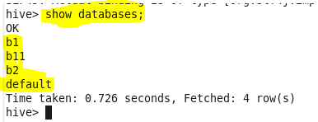

We have created database named **custom** below.

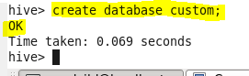

To work on the database named **custom,** we have given the below highlighted query.

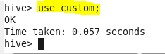

To display the **current working Database**, we have given the below highlighted query. Here, we can say that current Database is **custom.**



Now In custom database, we are creating **table** named **temperature_data.** Last line denotes that the file we are going to load into this table is delimited(separated) fields by ‘,’.

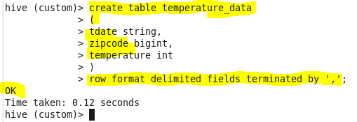

We have described the table **temperature_data** below.

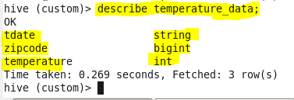

Now it is loaded from local machine path **‘/home/acadgild/hive/dataset_Session14.txt’** to table named **temperature_data**. 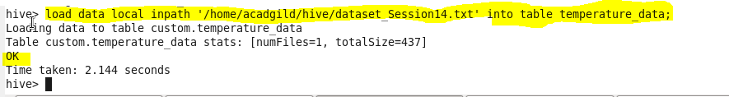

We can also say as the data is loaded from local machine to HDFS from the below screenshot.

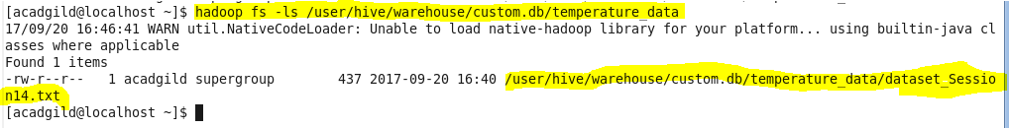

We have displayed the contents of table named **temperature_data** that was loaded from **dataset_Session14.txt.**

